**BISMA**

**Model Answer Paper**

**MCA IV Sem**

**Paper :- Artificial Intelligence**

Duration 2 hrs Max Marks 20

Each question carries one mark

1. What is artificial intelligence?

Artificial Intelligence is an area of computer science that emphasizes the creation of intelligent machine that work and reacts like humans.

1. What are the various areas where AI (Artificial Intelligence) can be used?

Artificial Intelligence can be used in many areas like Computing, Speech recognition, Bio-informatics, Humanoid robot, Computer software, Space and Aeronautics’s etc.

1. Which is not commonly used programming language for AI?

Perl language is not commonly used programming language for AI.

1. What is Prolog in AI?

In AI, Prolog is a programming language based on logic.

1. What does a production rule consist of?

The production rule comprises of a set of rule and a sequence of steps.

Each carries 2 marks:

1. What is an artificial intelligence Neural Networks?

Artificial intelligence Neural Networks can model mathematically the way biological brain works, allowing the machine to think and learn the same way the humans do- making them capable of recognizing things like speech, objects and animals like we do.

1. Give an explanation on the difference between strong AI and weak AI.

Strong AI makes strong claims that computers can be made to think on a level equal to humans while weak AI simply predicts that some features that are resembling to human intelligence can be incorporated to computer to make it more useful tools.

Each carries 2.5 marks

1. What are frames and scripts in “Artificial Intelligence”?

Frames are a variant of semantic networks which is one of the popular ways of presenting non-procedural knowledge in an expert system. A frame which is an artificial data structure is used to divide knowledge into substructure by representing “stereotyped situations’. Scripts are similar to frames, except the values that fill the slots must be ordered. Scripts are used in natural language understanding systems to organize a knowledge base in terms of the situation that the system should understand.

1. What is FOPL stands for and explain its role in Artificial Intelligence?

FOPL stands for First Order Predicate Logic, Predicate Logic provides

a) A language to express assertions about certain “World”

b) An inference system to deductive apparatus whereby we may draw conclusions from such assertion

c) A semantic based on set theory

One question of 7 marks

1. State water jug problem with solution and production rules.

**Statement :-** We are given 2 jugs, a 4 liter one and a 3- liter one. Neither has any measuring markers on it. There is a pump that can be used to fill the jugs with water. How can we get exactly 2 liters of water in to the 4-liter jugs?

Solution:-

The state space for this problem can be defined as

**{ ( i ,j ) i = 0,1,2,3,4 j = 0,1,2,3}**

‘i’ represents the number of liters of water in the 4-liter jug and ‘j’ represents the number of liters of water in the 3-liter jug. The initial state is ( 0,0) that is no water on each jug. The goal state is to get ( 2,n) for any value of ‘n’.

To solve this we have to make some assumptions not mentioned in the problem. They are

**1. We can fill a jug from the pump.**

**2. we can pour water out of a jug to the ground.**

**3. We can pour water from one jug to another.**

**4. There is no measuring device available.**

The various operators (Production Rules) that are available to solve this problem may be stated as given in the following figure .

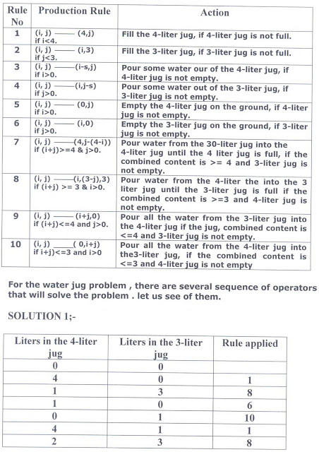

1. 