BISMA

Model Answer Paper
MCA IV Sem
Paper- Data Warehousing & Data Mining

Time: 2 hrs MM: 20

[I] Answer the following questions. (4*1=4)
Q1- What is meta data repository?
Ans. A metadata repository is a database created to store metadata. Metadata is information about the structures that contain the actual data.

Q2- What are the challenges of KDD?
Ans. Challenges of KDD is-
- Larger Databases
- High Dimensionality
- Overfitting
- Assessment of Statistical Significance
- User Interaction and Prior Knowledge
- Integration with Other Systems
Q3- Define association rule.
Ans. Association rule mining is a procedure which is meant to find frequent patterns, correlations, associations, or causal structures from data sets found in various kinds of databases such as relational databases, transactional databases, and other forms of data repositories.

Q4- Define maximal frequent itemset.
Ans. It is a frequent itemset for which none of its immediate supersets are frequent.

[II]-Write the short note on following. (2*2=4)
Q1. Define Bayesian belief network.
Ans. Bayesian networks are a type of Probabilistic Graphical Model that can be used to build models from data and/or expert opinion.
They can be used for a wide range of tasks including prediction, anomaly detection, diagnostics, automated insight, reasoning, time series prediction and decision making under uncertainty. Figure 1 below shows these capabilities in terms of the four major analytics disciplines, Descriptive analytics,Diagnostic analytics, Predictive analytics and Prescriptive analytics.
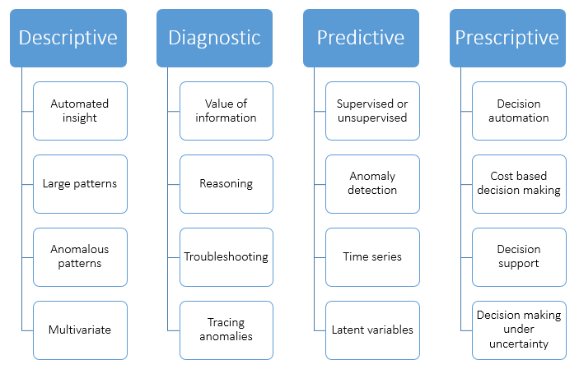

Probabilistic
Bayesian networks are probabilistic because they are built from probability distributions and also use the laws of probability for prediction and anomaly detection, for reasoning and diagnostics, decision making under uncertainty and time series prediction.

Q2. Compare MOLAP and ROLAP.

Ans. MOLAP vs ROLAP
S.No. | MOLAP | ROLAP
1 | Information retrieval is fast. | Information retrieval is comparatively slow.
2 | Uses sparse array to store data-sets. | Uses relational table.
3 | MOLAP is best suited for inexperienced users, since it is very easy to use. | ROLAP is best suited for experienced users.
4 | Maintains a separate database for data cubes. | It may not require space other than available in the Data warehouse.
5 | DBMS facility is weak. | DBMS facility is strong.

[III]- Attempt all Questions. Each question contain 2.5 marks (2.5*2=5)

Q1. Discuss FP-growth algorithm

Ans. FP-Growth
FP-Growth is an improvement of apriori designed to eliminate some of the heavy bottlenecks in apriori. The algorithm was planned with the bennefits of mapReduce taken into account, so it works well with any distributed system focused on mapReduce. FP-Growth simplifies all the problems present in apriori by using a structure called an FP-Tree. In an FP-Tree each node represents an item and it's current count, and each branch represents a different association.
The whole algorithm is divided in 5 simple steps. Here we have a simple example:
Our client is named Mario and here we have his transactions:
T_{Mario}= [ [beer, bread, butter, milk] , [beer, milk, butter], [beer, milk, cheese] , [beer, butter, diapers, cheese] , [beer, cheese, bread] ]

Step 1:
The first step is we count all the items in all the transactions
T_{Mario}= [ beer: 5, bread: 2, butter: 3, milk: 3, cheese: 3, diapers: 1]

Step 2:
Next we apply the threshold we had set previously. For this example let's say we have a threshold of 30% so each item has to appear at least twice.
T_{Mario}= [ beer: 5, bread: 2, butter: 3, milk: 3, cheese: 3, diapers: 1]

Step 3:
Now we sort the list according to the count of each item.
T_{MarioSorted} = [ beer: 5, butter: 3, milk: 3, cheese: 3, bread: 2]

Step 4:
Now we build the tree. We go through each of the transactions and add all the items in the order they appear in our sorted list.
Transaction to add= [beer, bread, butter, milk] 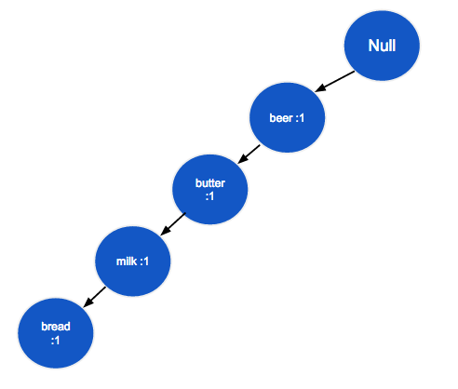
Transaction 2: [beer, milk, butter]
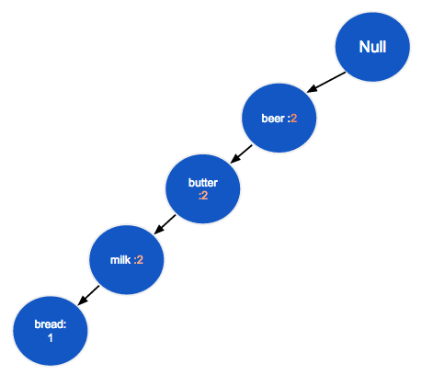
Transaction 3=[beer, milk, cheese]
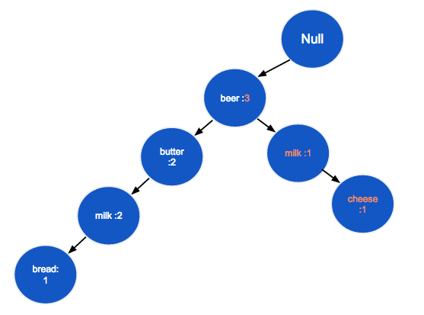
Transaction 4=[beer, cheese, bread]
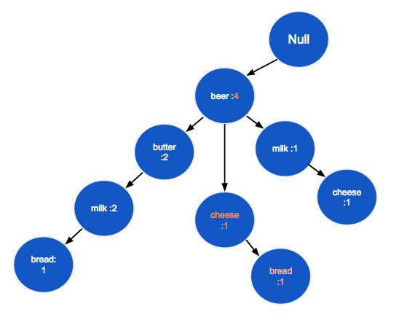
Transaction 5=[beer, cheese, diapers]
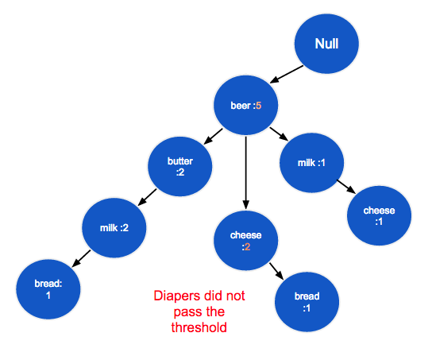

Step 5:
In order to get the associations now we go through every branch of the tree and only include in the association all the nodes whose count passed the threshold.
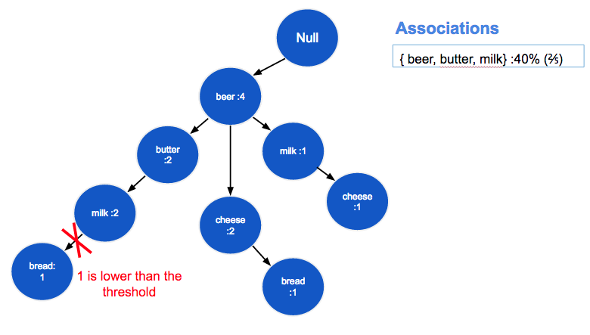
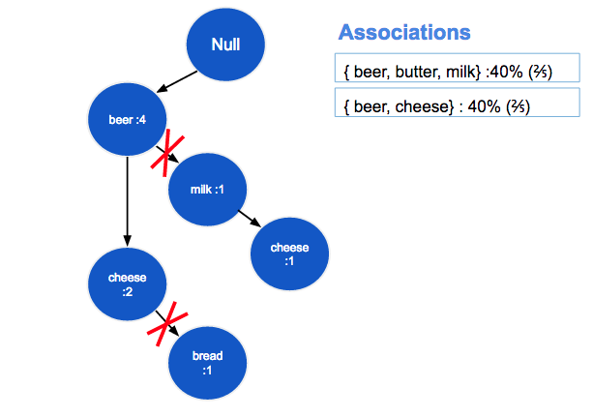

FP-Growth Biggest Advantages
The biggest advantage found in FP-Growth is the fact that the algorithm only needs to read the file twice, as opossed to apriori who reads it once for every iteration.
Another huge advantage is that it removes the need to calculate the pairs to be counted, which is very processing heavy, because it uses the FP-Treee. This makes it O(n) which is much faster than apriori.
The FP-Growth algorithm stores in memory a compact version of the database.

FP-Growth Bottlenecks
The biggest problem is the interdependency of data. The interdependency problem is that for the parallelization of the algorithm some that still needs to be shared, which creates a bottleneck in the shared memory.

Q2. Discuss the Apriori algorithm for discovering the frequent item sets.

Ans. Apriori Algorithm
The Apriori algorithm is based on the fact that if a subset S appears k times, any other subset S' that contains S will appear k times or less. So, if S doesn't pass the minimum support threshold, neither does S'. There is no need to calculate S', it is discarded a priori.
Now we're going to show you an example of this algorithm.
Let's suppose we have a client Mario with transactions [ [beer, wine, rum], [beer, rum, vodka], [beer, vodka], [beer, wine, rum] ], and a minimum support threshold m of 50 % (2 transactions).

First step: Count the singletons & apply threshold
The singletons for Mario are:
beer: 4,
wine: 2,
rum: 3,
vodka: 2
All of the single items appear m or more times, so none of them are discarded.

Second step: Generate pairs, count them & apply theshold
The pairs created were: { {beer, wine}, {beer, rum}, {beer, vodka}, {wine, rum}, {wine, vodka}, {rum, vodka} }.
Now we proceed to count them and applying the threshold.
{beer, wine}: 2
{beer, rum}: 3
{beer, vodka}: 2
{wine, rum}: 2
{wine, vodka}: 0
{rum, vodka}: 1
{wine, vodka} and {rum, vodka} have not passed the threshold, so they are discarded and any other subcombination both of them can generate.
The remaining pairs are put into a temporal associations set.
Assocs = {{beer, wine}, {beer, rum}, {beer, vodka}, {wine, rum}}

Step N: Generate triplets, quadruplets, etc., count them, apply threshold and remove containing itemsets.
We generate triplets from our pairs.
Triplets = { {beer, wine, rum}, {beer, wine, vodka}, {beer, rum, vodka}, {wine, rum, vodka} }.
Now we count them:
{beer, wine, rum}: 2
{beer, wine, vodka}: 0
{beer, rum, vodka}: 1
{wine, rum, vodka}: 0
Only {beer, wine, rum} has passed the threshold, so now we proceed to add it to Assocs, but first, we have to remove the subsets that {beer, wine, rum} contains.
Before adding our remaining triplet Assocs looked like this: { {beer, wine}, {beer, rum}, {beer, vodka}, {wine, rum} }.
When we add the triplet and remove the subsets that are inside it {beer, wine}, {beer, rum} and {wine, rum} are the ones that should go.
Assocs now look like { {beer, wine, rum}, {beer, vodka} }, and this is our final result.
If we had more than 1 triplet after applying the threshold, we should proceed to generating the quadruplets, counting them, applying the threshold, adding them to Assocs and removing the subsets that each quadruplet contains.

Disadvantages of Apriori
- The candidate generation could be extremely slow (pairs, triplets, etc.).
- The candidate generation could generate duplicates depending on the implementation.
- The counting method iterates through all of the transactions each time.
- Constant items make the algorithm a lot heavier.
- Huge memory consumption

Advantages of Apriori
The Apriori Algorithm calculates more sets of frequent items.

[IV]- Attempt any one Question. Each question contain 7 marks (7*1=7)
Q1- Explain data warehouse architecture with a neat diagram.
Ans. The business analyst get the information from the data warehouses to measure the performance and make critical adjustments in order to win over other business holders in the market. Having a data warehouse offers the following advantages −
- Since a data warehouse can gather information quickly and efficiently, it can enhance business productivity.
- A data warehouse provides us a consistent view of customers and items, hence, it helps us manage customer relationship.
- A data warehouse also helps in bringing down the costs by tracking trends, patterns over a long period in a consistent and reliable manner.
To design an effective and efficient data warehouse, we need to understand and analyze the business needs and construct a business analysis framework. Each person has different views regarding the design of a data warehouse. These views are as follows −
- The top-down view − This view allows the selection of relevant information needed for a data warehouse.
- The data source view − This view presents the information being captured, stored, and managed by the operational system.
- The data warehouse view − This view includes the fact tables and dimension tables. It represents the information stored inside the data warehouse.
- The business query view − It is the view of the data from the viewpoint of the end-user.

Three-Tier Data Warehouse Architecture
Generally a data warehouses adopts a three-tier architecture. Following are the three tiers of the data warehouse architecture.
- Bottom Tier − The bottom tier of the architecture is the data warehouse database server. It is the relational database system. We use the back end tools and utilities to feed data into the bottom tier. These back end tools and utilities perform the Extract, Clean, Load, and refresh functions.
- Middle Tier − In the middle tier, we have the OLAP Server that can be implemented in either of the following ways.
  - By Relational OLAP (ROLAP), which is an extended relational database management system. The ROLAP maps the operations on multidimensional data to standard relational operations.
  - By Multidimensional OLAP (MOLAP) model, which directly implements the multidimensional data and operations.
- Top-Tier − This tier is the front-end client layer. This layer holds the query tools and reporting tools, analysis tools and data mining tools.
The following diagram depicts the three-tier architecture of data warehouse −
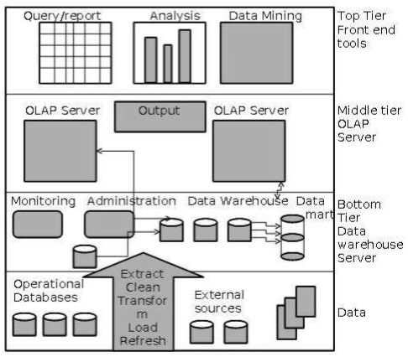

Data Warehouse Models
From the perspective of data warehouse architecture, we have the following data warehouse models −
- Virtual Warehouse
- Data mart
- Enterprise Warehouse

Virtual Warehouse
The view over an operational data warehouse is known as a virtual warehouse. It is easy to build a virtual warehouse. Building a virtual warehouse requires excess capacity on operational database servers.

Data Mart
Data mart contains a subset of organization-wide data. This subset of data is valuable to specific groups of an organization.

Enterprise Warehouse
- An enterprise warehouse collects all the information and the subjects spanning an entire organization
- It provides us enterprise-wide data integration.
- The data is integrated from operational systems and external information providers.

Q2- What are OLAP operations in the multidimensional data model? Explain.
Ans. Most times used interchangeably, the terms Online Analytical Processing (OLAP) and data warehousing apply to decision support and business intelligence systems. OLAP systems help data warehouses to analyze the data effectively.
The OLAP approach is used to analyze multidimensional data from multiple sources and perspectives. The three basic operations in OLAP are:
- Roll-up (Consolidation)
- Drill-down
- Slicing and dicing
Roll-up or consolidation refers to data aggregation and computation in one or more dimensions. It is actually performed on an OLAP cube. For instance, the cube with cities is rolled up to countries to depict the data with respect to time (in quarters) and item (type).
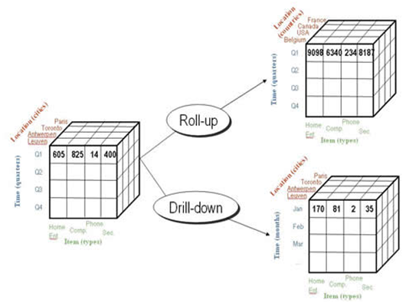
On the contrary, Drill-down operation helps users navigate through the data details. In the above example, drilling down enables users to analyze data in the three months of the first quarter separately. The data is divided with respect to cities, months (time) and item (type).
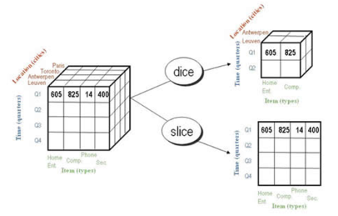
Slicing is an OLAP feature that allows taking out a portion of the OLAP cube to view specific data. For instance, in the above diagram, the cube is sliced to a two dimensional view showing Item(types) with respect to Quadrant (time).
Multidimensional model (MOALP)
The databases that are configured for OLAP use multidimensional data model, enabling complex analysis and ad hoc queries at a rapid rate. The multidimensional data model is analogous to relational database model with a variation of having multidimensional structures for data organization and expressing relationships between the data. The data is stored in the form of cubes and can be accessed within the confines of each cube. Mostly, data warehousing supports two or three-dimensional cubes; however, there are more than three data dimensions depicted by the cube referred to as Hybrid cube.
OLAP systems are mainly classified into three :
- MOLAP (Multi-dimensional OLAP)
- ROLAP (Relational OLAP) : works with relational databases
- HOLAP (Hybrid OLAP): database divides data between relational and specialized storage

